Eating and Drinking

Please cut my food into small pieces.

I may choke on larger pieces of food!

If I clamp my teeth down on the spoon, wait
and I will release it.

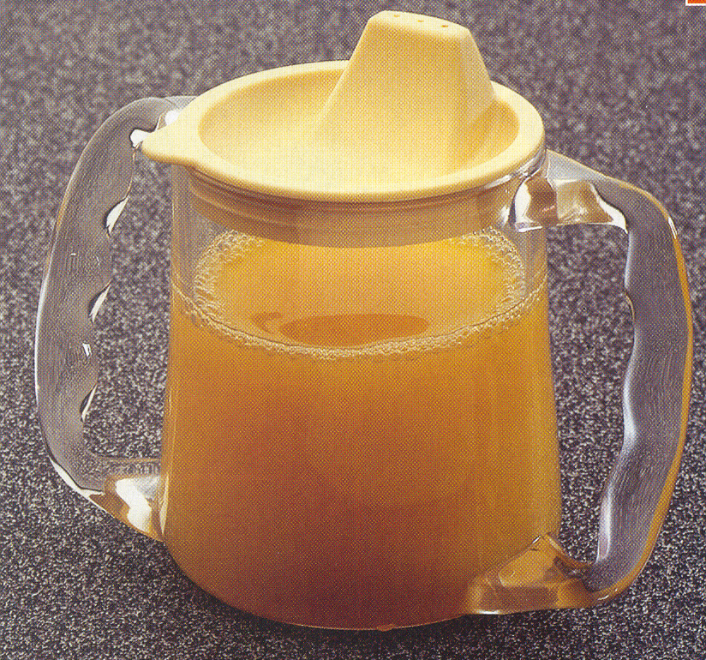

I drink from a special cup

Never use a glass container.

I will let you know when I’ve had enough to drink.

* My favourite drink is beer, but I’m only allowed a
very small amount

Eating and Drinking

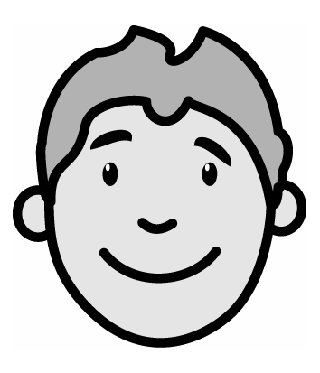

I like:

Fish and chips, sausages and mash, chips,
cake, chocolate and ice cream

Tea, coffee, cappuccino, cold drinks, fizzy drinks

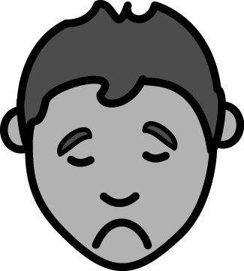
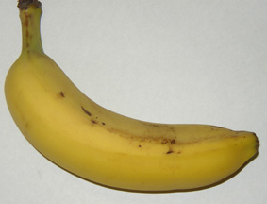

I don’t like

Peas, bananas, onions, mushrooms

